**ANNUAL REPORT 2022-23**

**SANKALP MANAV VIKAS SANSTHA, MAHARASHTRA**

**Women Empowerment & Livelihood Project, Tailoring Training Center**

Sankalp Manav Vikas Sanstha has been working amongst women from last 4 years on the **“Women Empowerment Project**”, of tailoring training center with the support of LTIMindtree CSR in Navi Mumbai, Pune and Thane which was prior LTI. In Raigad district, Panvel Block and Navi Mumbai, Digha, All-Cargo Group (Speedy Multimodes) (CSR) has been the funding partner since the year 2022 where **Women Empowerment & Livelihood Project** is implemented for marginalized women. Sankalp Manav Vikas Sanstha has been working for migrated, Marginalized widows, single, socially and economically challenged, illiterate, housewives, and who are doing domestic work, unprivileged women. We provide 3-month free tailoring training to the women. Over the last five years, Sankalp trained 1205 women and provided 1085 women with self-employment, employment, and placement. We provide sustainable livelihood to all our beneficiary women.

In the last five years, Sankalp reached a total of 139 vendors. For the self-development and sustainability of the women, provided life skills, marketing skills, business skills, and online marketing skills to them. After basic three months of tailoring training, the completion certificate is issued to the trained women, we also link them to the market. For the last five years, skilled women joined the production center, all women skilled beneficiaries received the self-employment through Production center.

**TAILORING TRAINING CENTER**

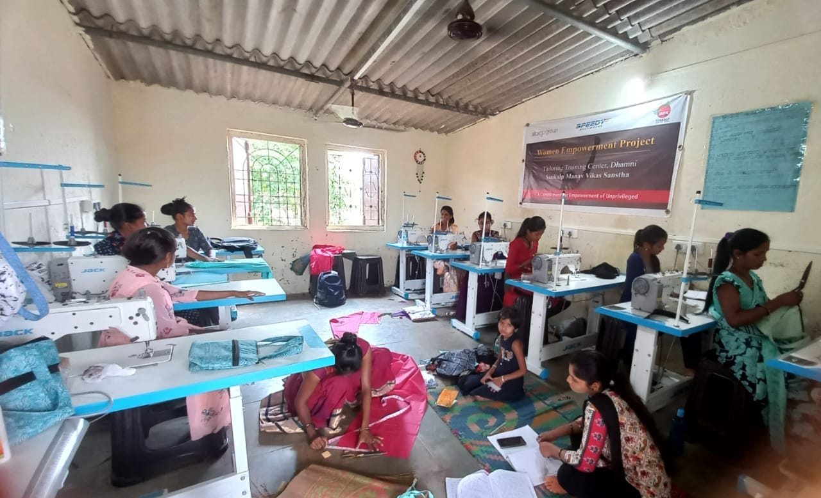

**Tailoring Training Center, Dhamni-Panvel, women are undergoing training and practical in the center.**

**CERTIFICATE DISTRIBUTION PROGRAM**

Women beneficiaries who are part of the **“Women Empowerment & Livelihood Project “Tailoring training center,** go through the basic and advanced three months tailoring training. After completion of the three months training, Certificate Distribution Program is conducted at each center to acknowledge women’s efforts through giving them the**” Completion Certificate”** by Sankalp Manav Vikas Sanstha

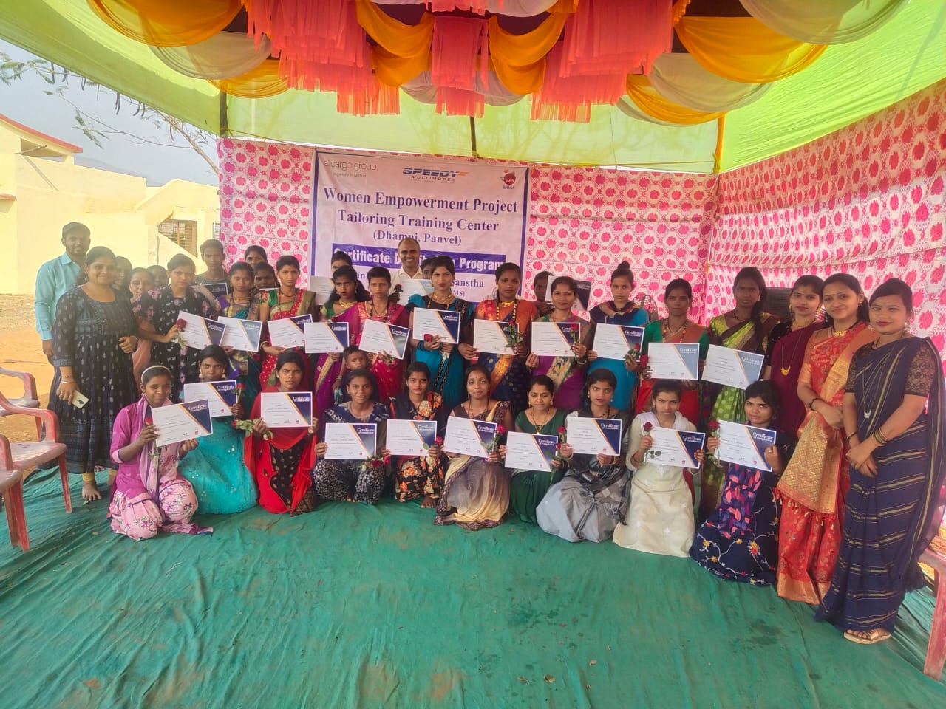

**Tailoring skill trained women received completion Certificate after the three months course**

**GUEST VISITS TO THE PROJECTS**

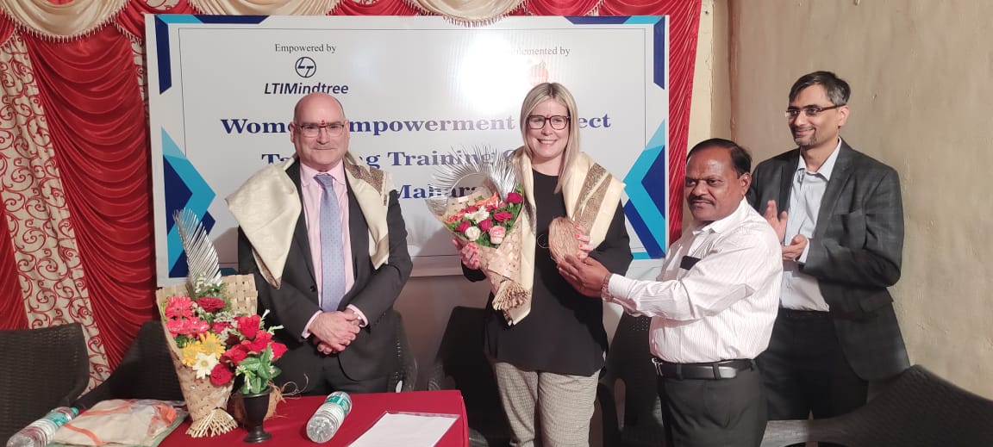

**Guests felicitated by Sudhakar Kshirsagar, Executive Director,Sankalp**

Mr. John Hayes and Emma Casbolt from UK Visited the Women Empowerment Project Tailoring Training Center, Pune along with the team of LTIMindtree. Guest and LTIMIndtree team interacted with training and Production center women beneficiaries and got to know the work and function of the Sankalp Manav Vikas Sanstha which has been working in collaboration with LTIMindtree.

**SOCIAL SECURITY AND ENTITLEMENT PROJECT**

**The Social Security and entitlement** project was introduced and implemented in collaboration with TATA Consulting Engineers Limited, **TCEndeavour** **(TATA Volunteers Week )** and Sankalp Manav Vikas Sanstha, Sankalp being an implementing partner worked in support with Tata Volunteers in the marginalized and mainly migrant communities in Digha, Navi Mumbai, and Rahatni, Pune improving and maximizing the usage of documents updating, Linkages of the essential documents such as Aadhar Card to Pan card, Updating Mobile number, Linking with the Bank accounts of urban marginalized and migrant slum communities, unorganized workers who are unaware of various government schemes, providing and guiding the necessary facilities for underprivileged citizens, bringing awareness in the people the attractive benefits, to the process and ways to obtain benefits and schemes offered through the Government to boost participation and conducting engaging activities and learning modules of the programs.

social assistance and mandatory social security contributory schemes mostly related to employment. Empowerment, Livelihood, helping communities to obtain various schemes such as Jobs related schemes, Livelihood opportunities, various trainings and benefits, Health, Disability benefits, Maternity benefits, Pension, Health insurance and medical benefits, gratuity, etc.

**Target group: -** the main target group for the awareness sessions were Women, elderly people, and children

**Output of the Project**

* Around 2800 beneficiaries educated on the social security and entitlement Project
* 600 families (BLD) base line data collected to link the essential documents and update the documents of migrants in the slum communities
* More than 60 women participants registered for the E-Shram card which is vital for unorganized section of the group
* Around 190 women are working on their pending documents to be updated and then link to the Aadhar and pan card

**Awareness Session**

**Following issues were covered and addressed in both Pune and Navi Mumbai locations during awareness sessions.**

1. **Aadhar card and Mobile number Linkage to the Bank**
2. **Aadhar – Pan Card Linkage**
3. **Linkage of mobile number to the Aadhar Card**
4. **E-Shram Card**

**Road Safety Awareness Rally**

Road Safety awareness rally was organized for school students and their parents in Ishwar Nagar, Digha and Rahatni in Pune.The main purpose of organizing the road safety awareness rally was to make aware of school going children and their parents about the importance of following the RTO rules and remind two wheelers, four-wheeler drivers their responsibilities towards others. Students from Schools participated in the road safety awareness rally. There were more than 145 participants including students from class 5th to 7th, parents, women beneficiaries, school teachers and team of staff of Sankalp at Navi Mumbai.

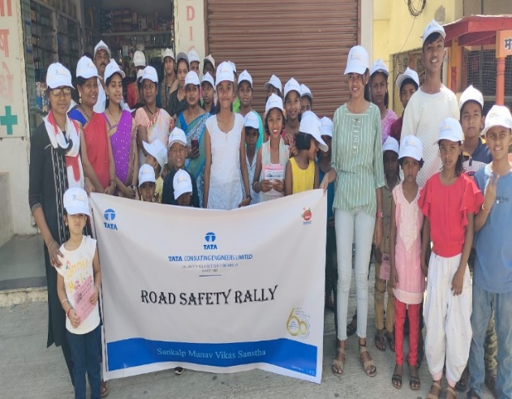 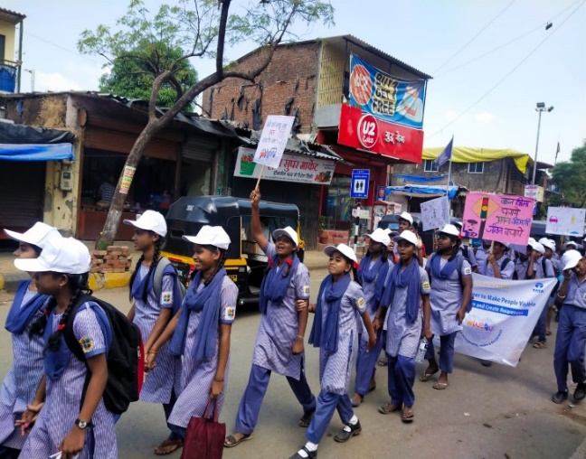

**Road Safety Rally in Rahatni, Pune School Students at the Rally in Navi Mumbai**

In Rahatni Pune, Chhatrapati Shivaji Maharaj Chowk to Kokne Chowk, From Shivar Chowk to Thopte lawns and returned to Chhatrapati Shivaji Maharaj Chowk road safety rally was organized with the support and help of animators and team. Total 140 women and school students participated in the road safety rally. Students and women, beneficiaries actively participated and gave loud slogans, held flap cards, giving the important messaged to the two-wheeler, four-wheeler drivers on safety, follow the rules set by the RTO.

**DLCC (Digital Learning Creativity Center)**

**DLCC (Digital Learning Creativity Center)** project is running in Pathri block of Parbhani District from year 2022 with the support of TDH (terre des hommes). Thus far in the 06 villages under the project running the DLCC where children are being given the digital learning in the centers. Sankalp Manav Vikas Sanstha along with local stake holders such as Anganwadi workers, Asha workers, VCPC, SMC, Gram Panchayat are great instruments in supporting to run the projects effectively and smoothly.

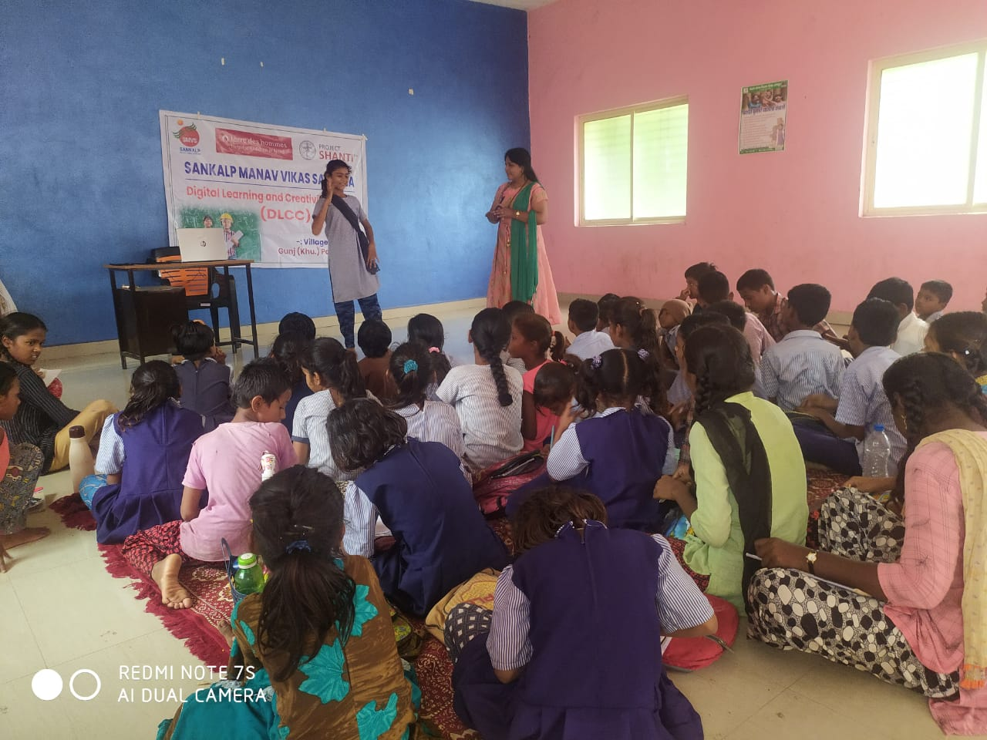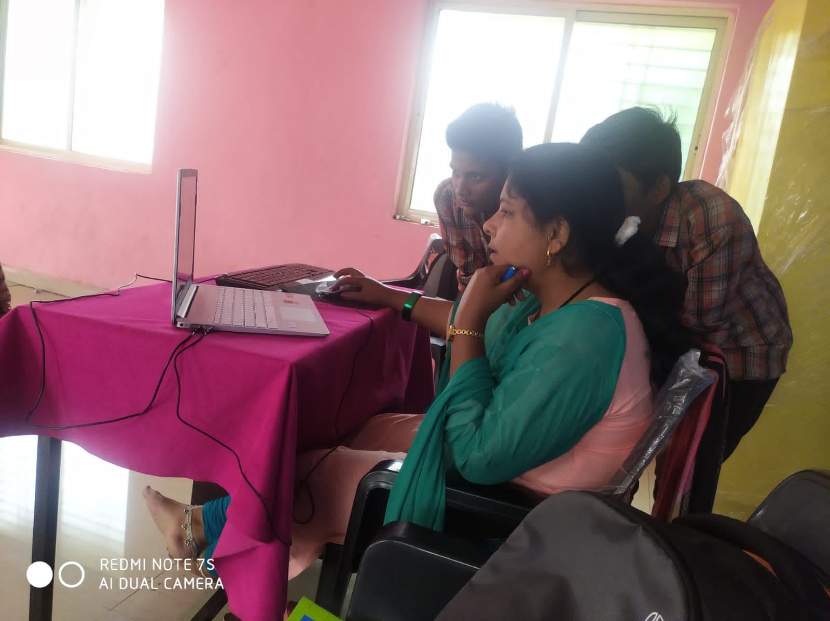

**Students at the DLCC Center Teacher teaching computers to students**

The children connected to the DLCC (Digital Learning Creativity Center) are the children of Migrants and sugar cane cutting workers who constantly are on move for the sugar cane cutting, Bricks making etc.

**Details of the Govt.schemes obtained chart in Parbhani Dist.**

|  |  |  |  |  |
| --- | --- | --- | --- | --- |
| **Sr. No** | **Name of Government Scheme** | **Number of Beneficiaries** | **How many villages were benefited from?** | **Total amount** |
| 01 | Gharkul Scheme (Ramai Awas) | 87 | 18 | 12006000 |
| 02 | Goat rearing scheme | 36 | 18 | 3600000 |
| 03 | Sewing Machine | 28 | 18 | 98000 |
| 04 | Well Plan | 31 | 18 | 8680000 |
| 05 | Threshing machine | 04 | 03 | 280000 |